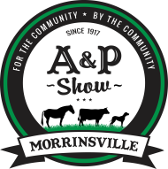
Morrinsville A & P Show

equestrian schedule
saturday 2ND March 2024

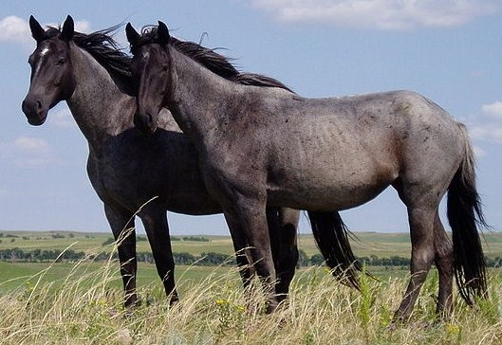

Ribbons Proudly Sponsored by

Led Sport Horse
Sport Horse Suitability
Ridden Horse - HOY Qualifier
Hacks & Park Hacks - HOY Qualifier
Saddle Hunters & Riding Horse - HOY Qualifier
Pony & Juvenile Section - HOY Qualifier
Lead Rein & First Ridden - HOY Qualifier
Working Hunter and Hunter Jumping Horse
Working Hunter and Hunter Jumping Ponies
Jellybean Gymkhana
Novice For Fun Adult Riding Class
Clydesdale, Carriage Driving, Gypsy Cobs & Gypsy Drums

Morrinsville Recreation Grounds (Anzac Avenue)
Gate Entry for Equestrian is Avenue Road South
MORRINSVILLE AGRICULTURAL & PASTORAL SOCIETY INC.
LIST OF OFFICERS:

Patrons: Mayor Adrienne Wilcock
Mr Walter Scott
Mr Russell Wilson

President: Mr Bruce McRobbie

Vice-President: Ms Fiona Braddick
Junior Vice President Mr Paddy O’Shea

Secretary: Ms Wilma van Orsouw

Treasurer: Mrs Sue Brownlie

General Committee: Messrs Ken Crowe, John Mead, Russell Wilson,
Ian Dibble, Ron Tuck, Evan McLennan, Peter Page,
David Mitchell, Kevin Hansen
Mesdames Yvonne Austin, Carol West, Raye McQuoid,
Viv Simmons, Jo Purcell, Linda Deane, Tammy Morris

Young Farmers Reps Sofie Adelaar, Steve Pratt

Honorary Solicitor: Allen Needham & Partners

Honorary Anexa FVC Vets Morrinsville
Veterinarians: JB Visser Vets, Morrinsville
Morrinsville Veterinary Clinic

Honorary Life Mr F Greenville, Mr D C Janes, Mrs P C Janes,
Members Mr W C Scott, Mr P Page, Mr K Crowe, Mr G Smallwood,
Mr R Wilson, Mrs Y Austin, Mr Bruce McRobbie
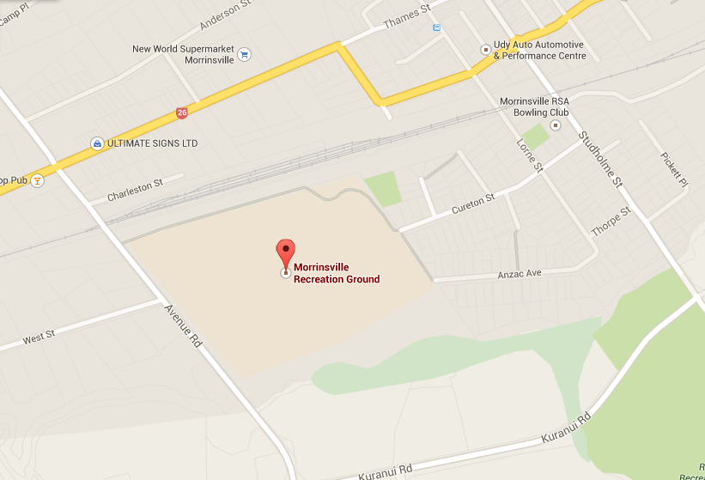
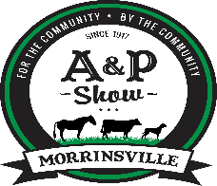
Entry Gate
Anzac Ave
Entry Gate
Avenue Rd
*EQUESTRIAN ONLY*

EQUESTRIAN
PAGE PAGE
ADMINISTRATION | 4 | Lead Sport Horse | 7
RULES FOR SHOW | 5 | Sport Horse Suitability | 7
pROTEST | 6 | Ridden Horse Section | 8
 |  | Hacks HOY  Park Hacks HOY | 8  8
ATTENTION  Please make sure you have your tickets available for the Gate  Keepers.  Failure to produce tickets on request will mean YOU WILL HAVE TO PAY.  AND NO REFUNDS WILL BE GIVEN  Late entries may be  accepted on the day but you will have to pay a gate entry fee to get in grounds as well as your late entry fee.  Start times are approximate only |  | Saddle Hunters HOY  Riding Horse HOY | 9  10
 |  | Rider Classes HOY  Working Hunters  Hunter Jumping | 10  11  11
 |  | Show Pony HOY | 12
 |  | Rider Classes HOY | 12
 |  | Saddle Hunter Pony HOY | 13
 |  | Working Hunter Pony  Hunter Jumping Pony | 13  14
 |  | Lead Rein HOY | 14
 |  | First Ridden HOY | 15
 |  | Tweens & Teens Gymkhana | 16
 |  | Novice for Fun Adult Riding Classes | 17
 |  | Clydesdale | 18
 |  | Carriage driving | 19
 |  | Gypsy Cob | 20

Entries & Payments
• Entries are to be received on or before the 19th February.
• Entries will be taken in all sections on the day, but a penalty will be added for entries that are late unless the sections only take the entries on the day and only these sections will have no penalty added.
• Tickets are to be produced to the Gate Person, otherwise you will be required to pay to enter. So do not forget your tickets, there will be no refunds given.
• All entries must be printed clearly.
• All entry forms must be signed by a person 18 years of age and over
• OnLine entries will be available through Main Events at www.main-events.co.nz
Alternatively entries will be accepted through post or email using the entry form supplied.
- Prize money will be paid directly into your bank account after the show.
• Payments can be made via Internet Banking - BNZ Morrinsville account number: 02-0368-0024297-00 and you must put the name on the entry form and section as reference.
• Phone: 0272943153
• Email: morrinsvilleshow@gmail.com
• Post: Morrinsville A & P Society,
P O Box 284,
Morrinsville 3340

Enquiries: Prefer email please, note phone messages and texts will be replied to after business hours.

TO ALL WINNERS OF TROPHIES
Please note that after you have been presented with your cup or
trophy, it will be taken to the Office for engraving.
Our Engraver will have it ready for you to collect at the
Office to take home on the day.
PICK UP FROM THE OFFICE BEFORE YOU LEAVE, SIGN AND
RECEIVE YOUR CUP

RULES FOR THE SHOW

RIBBONS KINDLY SPONSORED BY PROPERTY BROKERS

ENTRIES CLOSE 19TH FEBRUARY - LATE ENTRIES AND ENTRIES ON THE DAY WILL BE ACCEPTED WITH A LATE ENTRY FEE AND YOU WILL HAVE TO PAY A GATE ENTRY IF THERE IS NOT ENOUGH TIME TO GET YOU YOUR TICKETS. WHICH IS NOT REFUNDABLE.

RULES:

Clean Sport- This applies to all sections of the A&P Show. Any animal maybe be tested for drugs or forbidden substances at any Show under the By Laws and Regulations adopted by the RAS and procedures adopted by the CSIC.

Exhibitors or Persons entering or competing in Shows or Events affiliated to the RAS shall be deemed to accept and be bound by these By-Laws Regulations & Procedures.

Drugs & Forbidden Substances means any substance capable of effecting speed, stamina, courage, conformation or conduct of an animal by its action upon or cardio-vascular, respiratory, alimentary, digestive, musco skeletal or urogenital systems.

The following practices are banned from the Equestrian section of all A & P Shows. From the time any animal enters the grounds of any Show or Event or competes in any class or event, the Society or its duly appointed officer shall have the powers to order a drug test and if a test is ordered, the existing CSIC rules suitably adapted in accordance with the type of animal being tested and procedures and fines shall apply.

Ages – Age of Riders/Handlers are as at 1 August 2023. Horses/Ponies 3 years and under are not to be ridden.

Please note that the Morrinsville A & P Society is no longer registered for GST.

Refunding Entry Fees: A refund of fees will be made on presentation of a doctor’s or Veterinary Certificate, at the discretion of the committee. Please note that the on-line fees are non-refundable.

All entries received must be paid for when the entry is submitted
.
RAS Equestrian levy of $1.25 per entry is additional to the entry fee, as per entry form.

Attendant's tickets for exhibitors with a large number of horses will be issued at the rate of 1 per 3 exhibits on application to the Secretary.

Entries close 19th February, LATE entries are liable for an additional fee of $20.00 per horse/pony.

Each exhibitor must supervise and control their animals at all times and shall be liable for any hazards created or accident, illness or damage caused by the action of themselves or their animals at the show grounds. Exhibitors must comply with appropriate Animal Legislation and the Health & Safety in Employment Act 2015 and amendments thereafter. By entering the show you agree to abide by the terms and conditions of the Morrinsville A & P Society.

If suitable, classes with less than three entries may be combined.

For classes with a small number of entries Prize Money will be paid as follows:
Three competitors or less – 1st Prize only will be paid out
Four competitors – 1st and 2nd prizes will be paid out
Five competitors or more – 1st, 2nd and 3rd prizes will be paid.

No person is permitted in any Judging Ring without express permission from the Head Steward of that ring.
Only persons directly responsible for an Exhibit are permitted in the marshalling area.

The Morrinsville A & P Society or any other organisations in conjunction with the show will not be held accountable for any cancellation of all or part of the show. Refunds will be looked at due to unforeseen circumstances and you will be contacted accordingly

Pony & Juvenile Section:
- All entries must be in the name of the Bonafede owner.
- All persons competing in Horse and Pony Rings do so at their own risk and must wear hard hats in jumping events.
- The Morrinsville A & P Society reserves the right to amalgamate or delete classes where there is no competition.
- The use of tranquillizers, stimulants, or any drugs capable of affecting the performance of horses & ponies is forbidden

Hats and Safety Helmets:
In all cases current Worksafe New Zealand rules prevail.
All Riders including harness drivers with the exclusion of heavy horse (Clydesdale) working classes, competing at RAS affiliated A&P Show/ Events must wear protective head gear, which includes a retaining harness, secured to the shell at more than 2 points. Such headgear must be worn with the chinstrap properly adjusted and fastened when in the arena or ring, practice area, collecting rings, or anywhere else within a Showground or the grounds of an affiliated event. Hats/ Helmets must conform with one of the current approved safety standards. These standards maybe subject to change but the list can be found at www.ras.org.nz - Equestrian. RAS will advise any changes via their website and Facebook. All hats/ helmets that conform must be identified by the current tag system implemented by NZPCA, ESNZ and RAS. Please Note New ‘Yellow’ Tags regulations come in to force on 1 August 2023.

Whisker and Inner Ear Trimming
From 1 January 2022, the trimming of a horse/pony’s whiskers, eye and inner ear hair is banned for any
horses/ponies exhibiting or competing at affiliated A&P Shows or Kindred Events

Protests: Covering all Sections.
All protests must be in writing and must be entered with the Secretary no later than 15 minutes after the event. The party entering a protest must deposit $100.00
The deposit will be returned if the protest is sustained. The Committee will decide all protests as soon as practicable and there shall be no appeal from their decision.
Protest Committee are: President & (Secretary or Vice President) and Chief Steward of the ring concerned.

RIDDEN HORSE SECTION: Please Note: Height certificates must be available in the ring.

In-Line Resolution Process Policy
“This Show supports the RAS system In-Line Resolution Policy, which will operate across all sections of affiliated Shows and will be offered for any inappropriate behavior towards Show Officials, Judges, fellow competitors or any other third party connected with the Show bringing the Equestrian Discipline into disrepute, or cases which are of a less serious nature to the above in accordance with the Conduct of Members, Owners, Lessees, Competitors and/or Exhibitors as provided in the RAS Equestrian Competitors and Judges Rulebook of the RAS Constitution.

Implementation of the Policy will be in accordance with the RAS Rules that accompanied this card, and full working of the Policy is available to view on the RAS Website.

Covid 19
- Covid 19 regulations and restrictions will be in place as per Government instructions at the time of the Show.
- Refunds will be at the discretion of the organising Committee and will be looked at for unforeseen circumstances and you will be contacted accordingly.
- The Morrinsville A & P Society or any other organizations in conjunction with the Show will not be held accountable for any cancellation of all or part of the show.
- If any competitor is showing flu-like symptoms, we advise that you do not attend this event.
- The Morrinsville A & P Society will follow government guide lines but will not be held responsible if Covid 19 is contracted at the Show.

SHOWING SECTION TIMETABLE 2024

LED SPORT HORSE SECTION
RIBBONS KINDLY SPONSORED BY PROPERTY BROKERS

Competitors note that the test for forbidden substances may be carried out during the show and that testing of all animals is at the owner’s risk. Testing for forbidden substances will be carried out under the RAS forbidden substance judicial committee procedures and rules. (Refer Rule 97 - RAS Judges and Competitors rule book and rule 55a of the RAS general rules and regulations).
* A party entering a protest must deposit $100.00 (See protest rules)
* Name of Horse must be stated on entry form where required.
PRIZES: 1st $12, 2nd $8, 3rd $6, 4th ribbon. Vouchers or Product may be given in place of prize money.
ENTRY FEE: $8.00 PER CLASS

Class 260: Best Presented Horse and Handler (Open to All)

Class 261: Foal or Yearling - Colt Filly or Gelding

Class 262: 2 & 3-year-old Colt, Filly or Gelding

CHAMPION AND RESERVE JUNIOR SPORT HORSE - To be judged from the winners of the above classes 261 and 262. The second placed Junior Sport Horse to the Champion to be judged alongside the remaining winner for Reserve Champion.

Class 264: Dry Mare 4 years and over

Class 265: Gelding 4 years and over

CHAMPION AND RESERVE CHAMPION SENIOR SPORT HORSE - To be judged from the winners of the above classes 264 and 265. The second placed Senior Sport Horse to the Champion to be judged alongside the remaining winner for Reserve Champion.

SUPREME CHAMPION SPORT HORSE

Sport Horse Suitability Classes
RIBBONS KINDLY SPONSORED BY PROPERTY BROKERS

Class 270: Suitability for Dressage under 4 years

Class 271: Suitability for Show Hacking under 4 years

Class 272: Suitability for Eventing under 4 years

Class 273: Suitability for Show Jumping under 4 years

Class 274: Suitability for Field Hunting under 4 years

Class 275: Suitability for Dressage 4 years and over

Class 276: Suitability for Show Hacking 4 years and over

Class 277: Suitability for Eventing 4 years and over

Class 278: Suitability for Show Jumping 4 years and over

Class 279: Suitability for Field Hunting 4 years and over

RIDDEN HORSE SECTION - HOY QUALIFIER
RIBBONS KINDLY SPONSORED BY PROPERTY BROKERS
Horse of Year qualifying is for the 2025 HOY

Hack, Park Hack, Saddle Hunters, Riding Horse,
Competitors are advised that the test for forbidden substances may be carried out during the Show and that testing of all animals is at the owner’s risk. Clean Sport - This applies to all sections of the Morrinsville A&P Show. Any animal may be tested for drugs or forbidden substances at any show under the By Laws and Regulations adopted by the RAS and the procedures adopted by the CSJC. Name of horse must be stated on entry form where required.

Prizes: 1st, $25, 2nd $15, 3rd $10, 4th Ribbon. Vouchers or Product may be given in place of prize money.
ENTRY FEE: $10 MEMEBERS, $12 NON-MEMBERS PER CLASS

Hack Ring - HOY QUALIFIER

Class 280: Novice Hack 0-2 wins

Class 281: Novice Hack 0-5 Wins

CHAMPION and RESERVE CHAMPION NOVICE HACK. To be judged from the winners of the above classes 280 and 281. The second placed Hack to the Champion to be judged alongside the remaining winners for Reserve Champion.

Class 282: Novice Paced and Mannered Hack 0-5 wins

Class 283: Open Lady's Hack on type Lady or Gent Rider

Class 284: Open Gentleman's Hack on type Lady or Gent Rider

Class 285: Open Hack over 158cm and not exceeding 163cm

Class 286: Open Hack over 163cms

CHAMPION and RESERVE CHAMPION OPEN HACK. To be judged from the winners of above classes 285 and 286 only. Second placed Hack to the Champion to be judged alongside the remaining winners for Reserve Champion.

Class 287: Open Paced and Mannered Hack

Park Hack - HOY QUALIFIER

Class 290: Novice Park Hack 0-2 wins

Class 291: Novice Park Hack 0-5 wins

CHAMPION and RESERVE CHAMPION NOVICE Park Hack. To be judged from the winners of above classes 290 and 291 (if applicable). Second placed Park Hack to the Champion to be judged alongside the remaining winners of Reserve Champion.

Class 292: Novice Paced & Mannered Park Hack 0-5 wins

Class 293: Open Lady's Park Hack on type Lady or Gent Rider

Class 294: Open Gentleman's Park Hack on type Lady or Gent Rider

Class 295: Open Park Hack over 148 cm not exceeding 153 cm

Class 296: Open Park Hack over 153 cm and not exceeding 158 cm

CHAMPION and RESERVE CHAMPION OPEN PARK HACK. To be judged from the winners of the above
classes 295, and 296, only. Second placed Park Hack to the Champion to be judged alongside the remaining winners for Reserve Champion.

Class 297: Open Paced and Mannered Park Hack

Saddle Hunter - HOY QUALIFIER

Class 300: Novice Saddle Hunter 0 - 2 wins

Class 301: Novice Saddle Hunter 0 - 5 wins

CHAMPION and RESERVE CHAMPION NOVICE SADDLE HUNTER. To be judged from the winners of the above classes 300 and 301 (if applicable). Second placed Novice Saddle Hunter to the Champion to be judged alongside remaining winners for the Reserve Champion.

Class 302: Novice Paced and Mannered Saddle Hunter 0-5 wins

Class 303: Open Lady's Saddle Hunter on type Lady or Gent Rider
Ken Gibbons Memorial Trophy

Class 304: Open Gentleman's Saddle Hunter on type Lady or Gent Rider

Class 305: Open Saddle Hunter over 148 cm and not exceeding 163 cm

Class 306: Open Saddle Hunter over 163 cm

CHAMPION and RESERVE CHAMPION OPEN SADDLE HUNTER. To be judged from the winners of the above classes 305 and 306 only. Second placed Saddle Hunter to the Champion to be judged alongside the remaining winners for the Reserve Champion.

Class 307: Open Paced and Mannered Saddle Hunter

Riding Horse - HOY QUALIFIER

Class 310: Novice Riding Horse 0-2 wins

Class 311: Novice Riding Horse 0-5 wins

CHAMPION AND RESERVE CHAMPION NOVICE RIDING HORSE. To be judged from the winners of the above classes 310 and 311. Second placed Novice Riding Horse to the Champion to be judged alongside the remaining winners for the Reserve Champion.

Class 312: Novice Paced and Mannered Riding Horse 0-5 wins

Class 313: Open Lady's Riding Horse on type Lady or Gent Rider

Class 314: Open Gentleman's Riding Horse on type Gent or Lady Rider

Class 315: Open Riding Horse over 148 cm and not exceeding 163 cm

Class 316: Open Riding Horse over 163 cm

CHAMPION and RESERVE CHAMPION OPEN RIDING HORSE. To be judged from the winners of classes 315 and 316 only. Second placed Open Riding Horse to the Champion to be judged alongside the remaining winners for the Reserve Champion.

Class 317: Open Paced and Mannered Riding Horse

SUPREME HORSE CJ McSweeney Memorial Cup
Eligible Champion Hack, Champion Park Hack, Champion Saddle Hunter Champion Riding Horse

CHAMPION and RESERVE CHAMPION PACED AND MANNERED HORSE. To be judged from the winners of classes 287, 297, 307 and 317. Second place to the Champion to be judged alongside the remaining winners for the Reserve Champion.

Rider Classes - HOY QUALIFIER

Class 320: Novice Rider 17 years and over 0-5 wins

Class 321: Youth Rider 17 years and under 21 years

Class 322: Rider 21 years and under 40 years

Class 323: Rider 40 years and over.

CHAMPION AND RESERVE CHAMPION ADULT RIDER. To be judged from the winners of classes 321, 322 and 323. Second place to the champion to be judge alongside the winners from the Reserve Champion.

Working Hunter Classes - HOY QUALIFIER

Class 333: Novice Working Hunter Horse 0-5 wins

Class 334: Open Working Hunter over 148 cm and not exceeding 163 cm

Class 335: Open Working Hunter over 163 cm

CHAMPION AND RESERVE CHAMPION WORKING HUNTER HORSE to be judged from the winners of classes 334 and 335. Second place to the Champion to be judged alongside the remaining winners for Reserve Champion.

Hunter Jumping - HOY QUALIFIER

Class 337: Horse Eye Opener

Class 338: Novice Hunter over fences 0-5 wins

Class 339: Open Hunter over fences, over 148 cm and not exceeding 163cm

Class 340: Open Hunter over fences over 163cm

Class 341: Horse Wire Jump

Class 342: Open Hunter

Entry Fee Members $20.00 Non-Members $24.00
Prize money 1st $50.00 2nd $30.00 3rd $20.00
Champion and Reserve Champion Hunter Jumping Horse – to be judged from the winners of classes 337, 339, 340, 341 & 342. Second placed Hunter to the Champion to be judged alongside the remaining winners for Reserve.

RIDDEN PONY SECTION - HOY QUALIFIER
RIBBONS KINDLY SPONSORED BY PROPERTY BROKERS

PROTEST: Refer to rules section
NOVICES MUST BE NOVICES ON DAY OF SHOW
NOTE: Rider may compete in only the Horse or Pony Section but not in both and ponies not exceeding148 cm may compete in the pony section only.
NAME: the name of pony MUST be stated on Entry form where required.
MEASURING: All ponies must have approved height certificates before entering the ring and certificates must be produced if requested by the Chief Steward. No measuring on Show Day.
RIDERS: All riders in this section must be under 17 years of age as at the 1st of August 2023
CLEAN SPORT testing MAY be carried out on Show Day
The Stewards reserve the right to alter the program should the occasion arise.
In all Ridden events an approved safety helmet is compulsory for all riders.
JJ SEALES CHALLENGE CUP donated by Mr. JJ Seales for Best Cared for Pony and equipment.
EBONY CUP donated by Mrs. C Tims for Grand Champion on Flat
Prizes: 1st $15.00, 2nd $10.00, 3rd $8.00, 4th Ribbon. Vouchers or Product may be given in place of prize money
ENTRY FEE: $7.00 UNLESS OTHERWISE STATED PER CLASS

Show Pony Classes - HOY QUALIFIER

Class 345: Best presented Show Pony – 148cm and under
JJ SEALES CHALLENGE CUP

Rider under 17 years to be judged on general conditions only. Conformation and soundness not to count and newness and quality of equipment secondary consideration.

Class 347: Novice Show Pony 0-2 wins not exceeding 148 cm

Class 348: Novice Show Pony 0-5 wins not exceeding 148 cm

CHAMPION and RESERVE CHAMPION NOVICE SHOW PONY NOT EXCEEDING 148 CM. To be judged from the winners of classes 347 and 348. Second place to the Champion to be judged alongside the remaining winners for Reserve Champion.

Class 350: Novice Paced and Mannered Show Pony 0-5 wins not exceeding 148 cm

Class 351: Open Show Pony not exceeding 128 cm

Class 352: Open Show Pony over 128 cm and not exceeding 138 cm

Class 353: Open Show Pony over 138 cm and not exceeding 148 cm

CHAMPION and RESERVE CHAMPION OPEN SHOW PONY NOT EXCEEDING 148 CM. To be judged from the winners of classes 351, 352 and 353. Second Placed Open Show Pony to the Champion to be judged alongside the remaining winners for Reserve Champion. Sashes kindly sponsored by Mr. F. Greenville.

Class 355: Open Paced and Mannered Show Pony not exceeding 128 cm

Class 356: Open Paced and Mannered Show Pony over 128 cm and not exceeding 138 cm

Class 357: Open Paced and Mannered Show Pony over 138 cm not exceeding 148 cm

CHAMPION and RESERVE CHAMPION OPEN PACED AND MANNERED SHOW PONY. To be judged from the winners of classes 355, 356 and 357. Second placed Open Paced and Mannered Show Pony to the Champion to be judged alongside the remaining winners for Reserve Champion.

Rider Class Pony - HOY QUALIFIER

Class 360: Junior Rider-Best Novice Junior Rider 0-5 Wins age as at 1st August 2023

Class 361: Junior Rider-Best Rider 11 years and under age as at 1st August 2023

Class 362: Junior Rider- Best Rider 12, 13, 14 years, age as at 1st August 2023

Class 363: Junior Rider Best Rider 15 and 16 years, age as at 1st August 2023

CHAMPION JUNIOR RIDER – To be judged from winners from classes 361, 362 and 363. Second placed rider to the Champion to be judged alongside the remaining winners for Reserve Champion.

Saddle Hunter Pony Classes - HOY QUALIFIER

Class 365: Best Presented Saddle Hunter Pony - 148 cm and under.
Rider under 17 years to be judged on general conditions only. Conformation and soundness not to count and newness and quality of equipment secondary consideration.

Class 369: Novice Saddle Hunter Pony 0-2 wins over 138 cm and not exceeding 148 cm

Class 370: Novice Saddle Hunter Pony 0-5 wins over 138 cm and not exceeding 148 cm

CHAMPION and RESERVE CHAMPION NOVICE SADDLE HUNTER PONY OVER 138 CM AND NOT EXCEEDING 148 CM. To be judged from the winners of classes 369 and 370. Second placed Saddle Hunter Pony to the Champion to be judged alongside the remaining winners for Reserve Champion.

Class 372: Novice Paced and Mannered Saddle Hunter Pony 0-5 wins not exceeding 148 cm

Class 373: Open Saddle Hunter Pony not exceeding 128 cm

Class 374: Open Saddle Hunter Pony over 128 cm and not exceeding 138 cm

Class 375: Open Saddle Hunter Pony over 138 cm and not exceeding 148 cm

CHAMPION AND RESERVE CHAMPION OPEN SADDLE HUNTER PONY to be judged from the winners of the above classes 373, 374 and 375. Second placed Open Saddle Hunter Pony to the Champion to be judged alongside the remaining winners for Reserve Champion. Sashes kindly sponsored by Mr. F. Greenville.

Class 377: Open Paced and Mannered Saddle Hunter Pony not exceeding 148 cm

GRAND CHAMPION PONY 148 CM AND UNDER. To be judged from Champion Show Pony and Champion Saddle Hunter Pony.

Working Hunter Pony - HOY QUALIFIER

Class 379: Novice Working Hunter Pony 0-5 Wins

Class 380: Open Working Hunter Pony not exceeding 138 cm

Class 381: Open working Hunter Pony over 138 cm and not exceeding 148 cm

CHAMPION AND RESERVE CHAMPION WORKING HUNTER PONY. To be judged from winners of classes 380 and 381. Second place to the Champion to be judged alongside the remaining winners for the Reserve Champion

Hunter Jumping Pony - HOY QUALIFIER

Class 383: Pony Eye Opener

Class 384: Novice Pony Hunter 0-5 wins

Class 385: Open Pony Hunter not exceeding 138 cm

Class 386: Open Pony Hunter over 138 cm and not exceeding 148 cm

Class 387: Pony Wire Jump

Class 388: Open Pony Hunter

Entry Fee Members $ 12.00 Prize Money: - 1st $30; 2nd $20; 3rd $15
Champion and Reserve Champion Hunter Jumping Pony. To be judged from the winners of classes 383, 385, 386, 387 and 388. Second place Hunter Jumping Pony to the Champion to be judged alongside the remaining winners for Reserve.

LEAD REIN SECTION - HOY QUALIFIER
RIBBONS KINDLY SPONSORED BY PROPERTY BROKERS

Rules:
* Hard riding helmet and riding boots to be worn. Refer to Pony Section
* Pony 128 cm and under
* Pony must be led by a leader/attendant (14 years and over) with the lead rein attached to the cavesson nose band of a snaffle bridle
* Walk and trot only
* Rider to be 4 years and under 8 as at 1st August 2023
* No spurs but a small cane may be carried
* 60% suitable and safeness - 40% conformation and paces
* Simple snaffle bridle
* Riders who compete in the F.R. and Open Pony Novice and Open Section are no longer eligible for the lead rein section
PRIZES: 1st $10, 2nd $8, 3rd $6
Ribbons: 1st - 4th
ENTRY: $6.00 PER CLASS

Class 390: Best presented Pony rider and handler

Class 391: Novice Lead Rein Pony 0 - 5 wins

Class 392: Open Lead Rein Pony not exceeding 123 cm

Class 393: Open Lead Rein Pony over 123 cm and not exceeding 128 cm

CHAMPION AND RESERVE CHAMPION OPEN LEAD REIN PONY To be judged from winners of Classes 391, 392 and 393. Second placed Lead Rein Pony to the Champion to be judged alongside the remaining winners for the Reserve Champion

Class 395: Open Paced and Mannered Lead Rein Pony

Class 396: Best Rider

FIRST RIDDEN SECTION - HOY QUALIFIER
RIBBONS KINDLY SPONSORED BY PROPERTY BROKERS

Rules:
* Hard Riding Helmet and riding boots to be worn (refer to Pony Section)
* Pony must not exceed 138 cm
* Rider to be under 10 years as at 1st August 2023
* Rider can only compete in this section for two seasons.
* Not to have competed in the Open Pony Section.
* Same unit is not to compete in Led Rein.
* Bridle to be of single rein.
* No spurs or side reins, but a small cane or whip not exceeding 68 cm in length with a 2 cm wide and 4 cm long flap may be carried.
* Walk and trot only, may be asked to canter in separate workout.
PRIZES: 1st $10, 2nd $8, 3rd $6
Ribbons 1st - 4th. Ribbons
ENTRY FEE: $6.00 PER CLASS
Entries Close 19th February

Class 400: Best presented Pony rider

Class 401: Novice First Ridden Pony 0 - 5 wins

Class 402: Open First Ridden Pony not exceeding 128 cm

Class 403: Open First Ridden Pony over 128 cm and not exceeding 138 cm

CHAMPION AND RESERVE OPEN FIRST RIDDEN PONY. To be judged from winners of Classes 401, 402 and 403. Second placed First Ridden Pony to the Champion to be judged alongside the remaining winners for the Reserve Champion.

Class 405: Open Paced and Mannered First Ridden Pony

Class 406: Novice Paced and Mannered First Ridden Pony 0-5wins

Class 407: Novice First Ridden Rider 0-5 wins

Class 408: Open First Ridden Rider

JELLYBEAN GYMKHANA

A fun, relaxed day with games. Ribbons for all events
STARTING TIME 11.30AM
$20.00 per Rider. $5.00 ground fee

- This is a fun event aimed at those riders with little or very limited riding experience. Thus, it is for Lead Rein, Beginner and Novice riders only. Mounts can either be pony or horse, Rider must not have entered any other class at this Show, (except for Lead Rein (classes 390-396) Dress is casual riding attire. Hard hats and suitable Footwear must be worn.
- Riders enter at their own risk. Morrinsville A & P Society disclaims all liability in the event of accident to competitors, spectators or property.
- Prefer entries before the Show sent with name, details and payment to morrinsvilleshow@gmail.com Late entries will be accepted till 11.00am on show day but you will have to pay a gate entry fee to get in the grounds.
- Age is taken as at the day of the Show.

RING 1 -10 YEARS OLD AND UNDER
RING 2 - 11 YEARS OLD AND UNDER 18 (MUST BE A NOVICE RIDER)

Class 430 10 YEARS OLD AND UNDER

- Best cared for mount and tack
- Walk and trot race
**five-minute break to set up cones for next two classes**
- Pairs riding (Steward will pair up riders – looking for teamwork)
- Musical coloured cones
- Pony best suited to beginner or younger rider
- Stewards Choice
- Bending pole race
***15-minute break to get ready for fancy dress***

- Fancy Dress

Class 439 11 TO 17 YEARS OLD (Inclusive)
- Best cared for mount and tack
- Walk and trot race
**five-minute break to set up cones for next two classes**
- Pairs riding (Steward will pair up riders – looking for teamwork)
- Musical coloured cones
- Pony best suited to beginner or younger rider
- Stewards Choice
- Bending pole race
***15-minute break to get ready for fancy dress***
- Fancy Dress

NOVICE FOR FUN ADULT RIDING CLASSES

A fun, relaxed day with games. Ribbons for all events

STARTING TIME 9.30AM

$25.00 per Rider. $5.00 ground fee

- This is a fun event for non-competitive riders aimed specifically at returning to riding, nervous or novice riders aged 18 years and over. Mounts can either be pony or horse, Rider must not have entered any other class at this Show. Dress is casual riding attire. Hard hats and suitable Footwear must be worn.
- Riders enter at their own risk. Morrinsville A & P Society disclaims all liability in the event of accident to competitors, spectators or property.
- Prefer entries before the Show sent with name. details and payment to morrinsvilleshow@gmail.com Late entries will be accepted till 9.00am. on show day but you will have to pay a gate entry fee to get in the grounds.
- Age is taken as at the day of the Show.

Class 448 RING 1 18 YEARS OLD AND OVER
- Best cared for horse and equipment
- Best walking horse
- Horse best suited to nervous or novice rider

**five-minute break to set up ring for next classes**

- Pairs riding (Steward will pair up riders, looking for team work)
- Musical coloured cones
- Pole bending race
- Stewards Choice

***15-minute break to get ready for best glammed up horse & rider***

- Best blinged up horse and rider/handle

CLYDESDALE
RIBBONS KINDLY SPONSORED BY PROPERTY BROKERS AND D W WILDE
JUDGING COMMENCES 9.30 A.M.
Prizes: 1st $25, 2nd $15, 3rd $10. Vouchers or Product may be given in place of prize money.
Order of work: Classes may be altered
ENTRY $8.00 PER CLASS

Clydesdale Classes

Class 600: Best turned-out Stallion, Colt or Gelding

Class 601: Stallion 3 years and over

Class 602: Colt 2 years

Class 603: Colt yearling

Class 604: Gelding any age
CHAMPION and CHAMPION RESERVE STALLION, YEARLING OR COLT. To be judged from winners of Classes 601, 602 and 603. Second placed Stallion, Yearling or Colt to the Champion to be judged alongside the remaining winners for the Reserve Champion.

Class 605: Best Turned-out Mare or Filly

Class 606: Mare 3 years and over

Class 607: Filly 2 years

Class 608: Filly yearling

Class 609: Foal born in the 2023/24 Season

CHAMPION AND RESERVE CHAMPION MARE OR FILLY.

Class 610: Best Yearling or two-year-old, colt or filly Bred by the Exhibitor (Clydesdale Horse Society Silver Medal)

SUPREME CHAMPION GOLD MEDAL North Island Clydesdale Society Championship

Heavy horse and working horse classes
Class 611: Ridden Clydesdale
Class 612: Long reining open class
Class 613: Pair of Horses in a Sledge over courses
Class 614: Single Horse in sledge over course
Class 615: Log Skidding (run under Waikato Heavy Horse Association rules)

CARRIAGE DRIVING
RIBBONS KINDLY SPONSORED BY PROPERTY BROKERS
Fees: $4.00 per class
Chief Steward: Lloyd Weal
Judge: TBC
Commences: 1:00pm
Prize money: 1st $15; 2nd $10; 3rd $5.

Please note
Entries close 19th February. Please see notes at the beginning of the Equestrian Schedule regarding entry terms and conditions.
Novice Pony/Horse: Not to have won a first place at an A&P Show. May compete in Open classes.
Novice Driver: Not to have won a first place at an A&P Show. May compete in Open Classes.

Classes:
Class 651: Novice Best Presented Turnout
Class 652: Novice Paced and Mannered – All Heights
Class 653: Novice Conformation – All Heights

Champion and Reserve Novice Pony/Horse.
Class 655: Open Best Presented Turnout
Class 656: Open Paced and Mannered – Up to and Including 108cm
Class 657: Open Conformation – Up to and Including 108cm
Class 658: Open Paced and Mannered – Over 108cm
Class 659: Open Conformation – Over 108cm

Champion and Reserve Open Horse/Pony
Supreme Champion (To be judged from the Champion Novice and Champion Open Winners)
Class 662: Unity workout. This class is judged on points out of 100. 30% conformation/quality of horse or pony, 30% performance of horse or pony, 10% vehicle, 10% harness, 10% harness, 10% driver, 10% overall impression. An individual workout will be provided to drivers prior to show day.
Class 663: Novice Driver
Class 664: Open Driver
Class 665: Ride and Drive. This class is run in two parts. Drive: The performance and complete turnout of the horse, harness and vehicle and driver will be considered. Ride: Riders are expected to wear correct riding attire and saddle and bridle (open riding bridle) to be clean, fit and in good condition. The driver and rider may be two different people. The ride and drive component will be performed as individual workouts, so that a driver or rider can compete with multiple turnouts.

***Afternoon tea break***
Class 666: Marathon Turnout
Class 667: Slalom – Trot Only – Up to and Including 108cm
Class 668: Slalom – Trot Only – Over 108cm
Class 669: Cone Course – Trot Only – Up to and Including 108cm
Class 670: Cone Course – Trot Only – Over 108cm
Class 671: Mini Obstathon – Any Pace – Up to and Including 108cm
Class 672: Mini Obstathon – Any Pace – Over 108cm
NEW ZEALAND GYPSY COB
All horses must be registered with the New Zealand Gypsy Cob Association at close of entries and owners must be member of the NZGCA.
ENTRIES - $8.00 PER CLASS.

Class 800: Best Presented, Pure-bred or part-bred Gypsy Cob, and Drum Horse any age
Pure-Bred Classes
Class 801: Purebred Adult, 4 Years and Over
Class 802: Purebred 2 or 3 Years Old
Class 803: Purebred Foal or Yearling

These classes 802 &803 may be combined if there are insufficient entries

CHAMPION AND RESERVE CHAMPION PURE BRED GYPSY COB. To be judged from the Winners of Classes 801, 802 & 803 Second Place getters to standby

Partbred Classes

Class 805: Partbred, Adult, 4 Years and Over
Class 806: Partbred, 2 or 3 Years Old
Class 807: Partbred, Foal or Yearling

Classes 806 and 807 may be combined if there are insufficient entries

CHAMPION AND RESERVE CHAMPION PART-BRED GYSPY COB. To be judged from the winners of classes 805, 806 and 807. Second place getters to standby

Class 810: Best Paced, Pure-Bred
Class 811: Best Paced, Part-Bred
Class 812: Best Mannered, Pure-Bred
Class 813: Best Mannered, Part-Bred

Classes to be combined if there are insufficient entries in any given class

Drum Horse Classes

Class 814: Drum Adult, 4 Years and Over
Class 815: Drum Youngstock, 3 Years and Under

CHAMPION AND RESERVE CHAMPION DRUM HORSE. To be Judged from the winners of classes 814 and 815. Second place getters to standby

Class 817: Best Paced Drum Horse
Class 818: Best Mannered Drum Horse

Ridden Gypsy Cob

To be split into purebred and part bred if there are sufficient entries

Class 819: Best Presented Pure and Part bred Combined
Class 820: Novice 0 - 5 Wins, Purebred and Part bred Combined
Class 821: Open Purebred and Part bred Combined

CHAMPION AND RESERVE CHAMPION RIDDEN GYPSY COB

Class 823: Best Paced and Mannered Purebred and Part bred Combined

Please support our 2024 sponsor
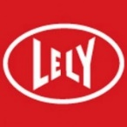
Anexa FVC Vet Services  Ashburn Clydesdale Stud  Bell Booth  BNZ Morrinsville  Bowers Bros Concrete  Butch Dog Food  Cambridge Grains  Cooper Aitken  D W Wilde  Ecolab  Farm Source  Farmlands Morrinsville  Goldpine  Harcourts, Kevin Deane Real Estate  L. J Hooker Morrinsville  Livestock Improvement Corporation  McGregors Farm Services  McLaren Rural Services  Mr B Swney  Mr & Mrs W Scott | Mr & Mrs M & R McQuoid  Mr & Mrs R Wilson  Morrinsville Decor  Morrinsville Flooring Xtra & Beds R us  NZ Farmers Livestock  New World Morrinsville  Noel Leemings  Norman’s Transport  Norwood Farm Machinery  Odlum Cable Installers  OSP Stock foods  Peter Glidden Honda Morrinsville  PGG Wrightson  Piako Group  Sadliers & Seddon Park Funeral Services  TradeZone  The ToolShed  Te Aroha Tractors  Waikato Purebred Jersey Breeders Club

The Committee of the
Morrinsville Agricultural & Pastoral Society Inc
would like to thank everyone who
have helped to make our show successful.
Special Thanks
To

Morrinsville A&P Society (Inc)
PO Box 284
Morrinsville 3340

Email: Morrinsvilleshow@gmail.com
Facebook: Morrinsville A & P Show

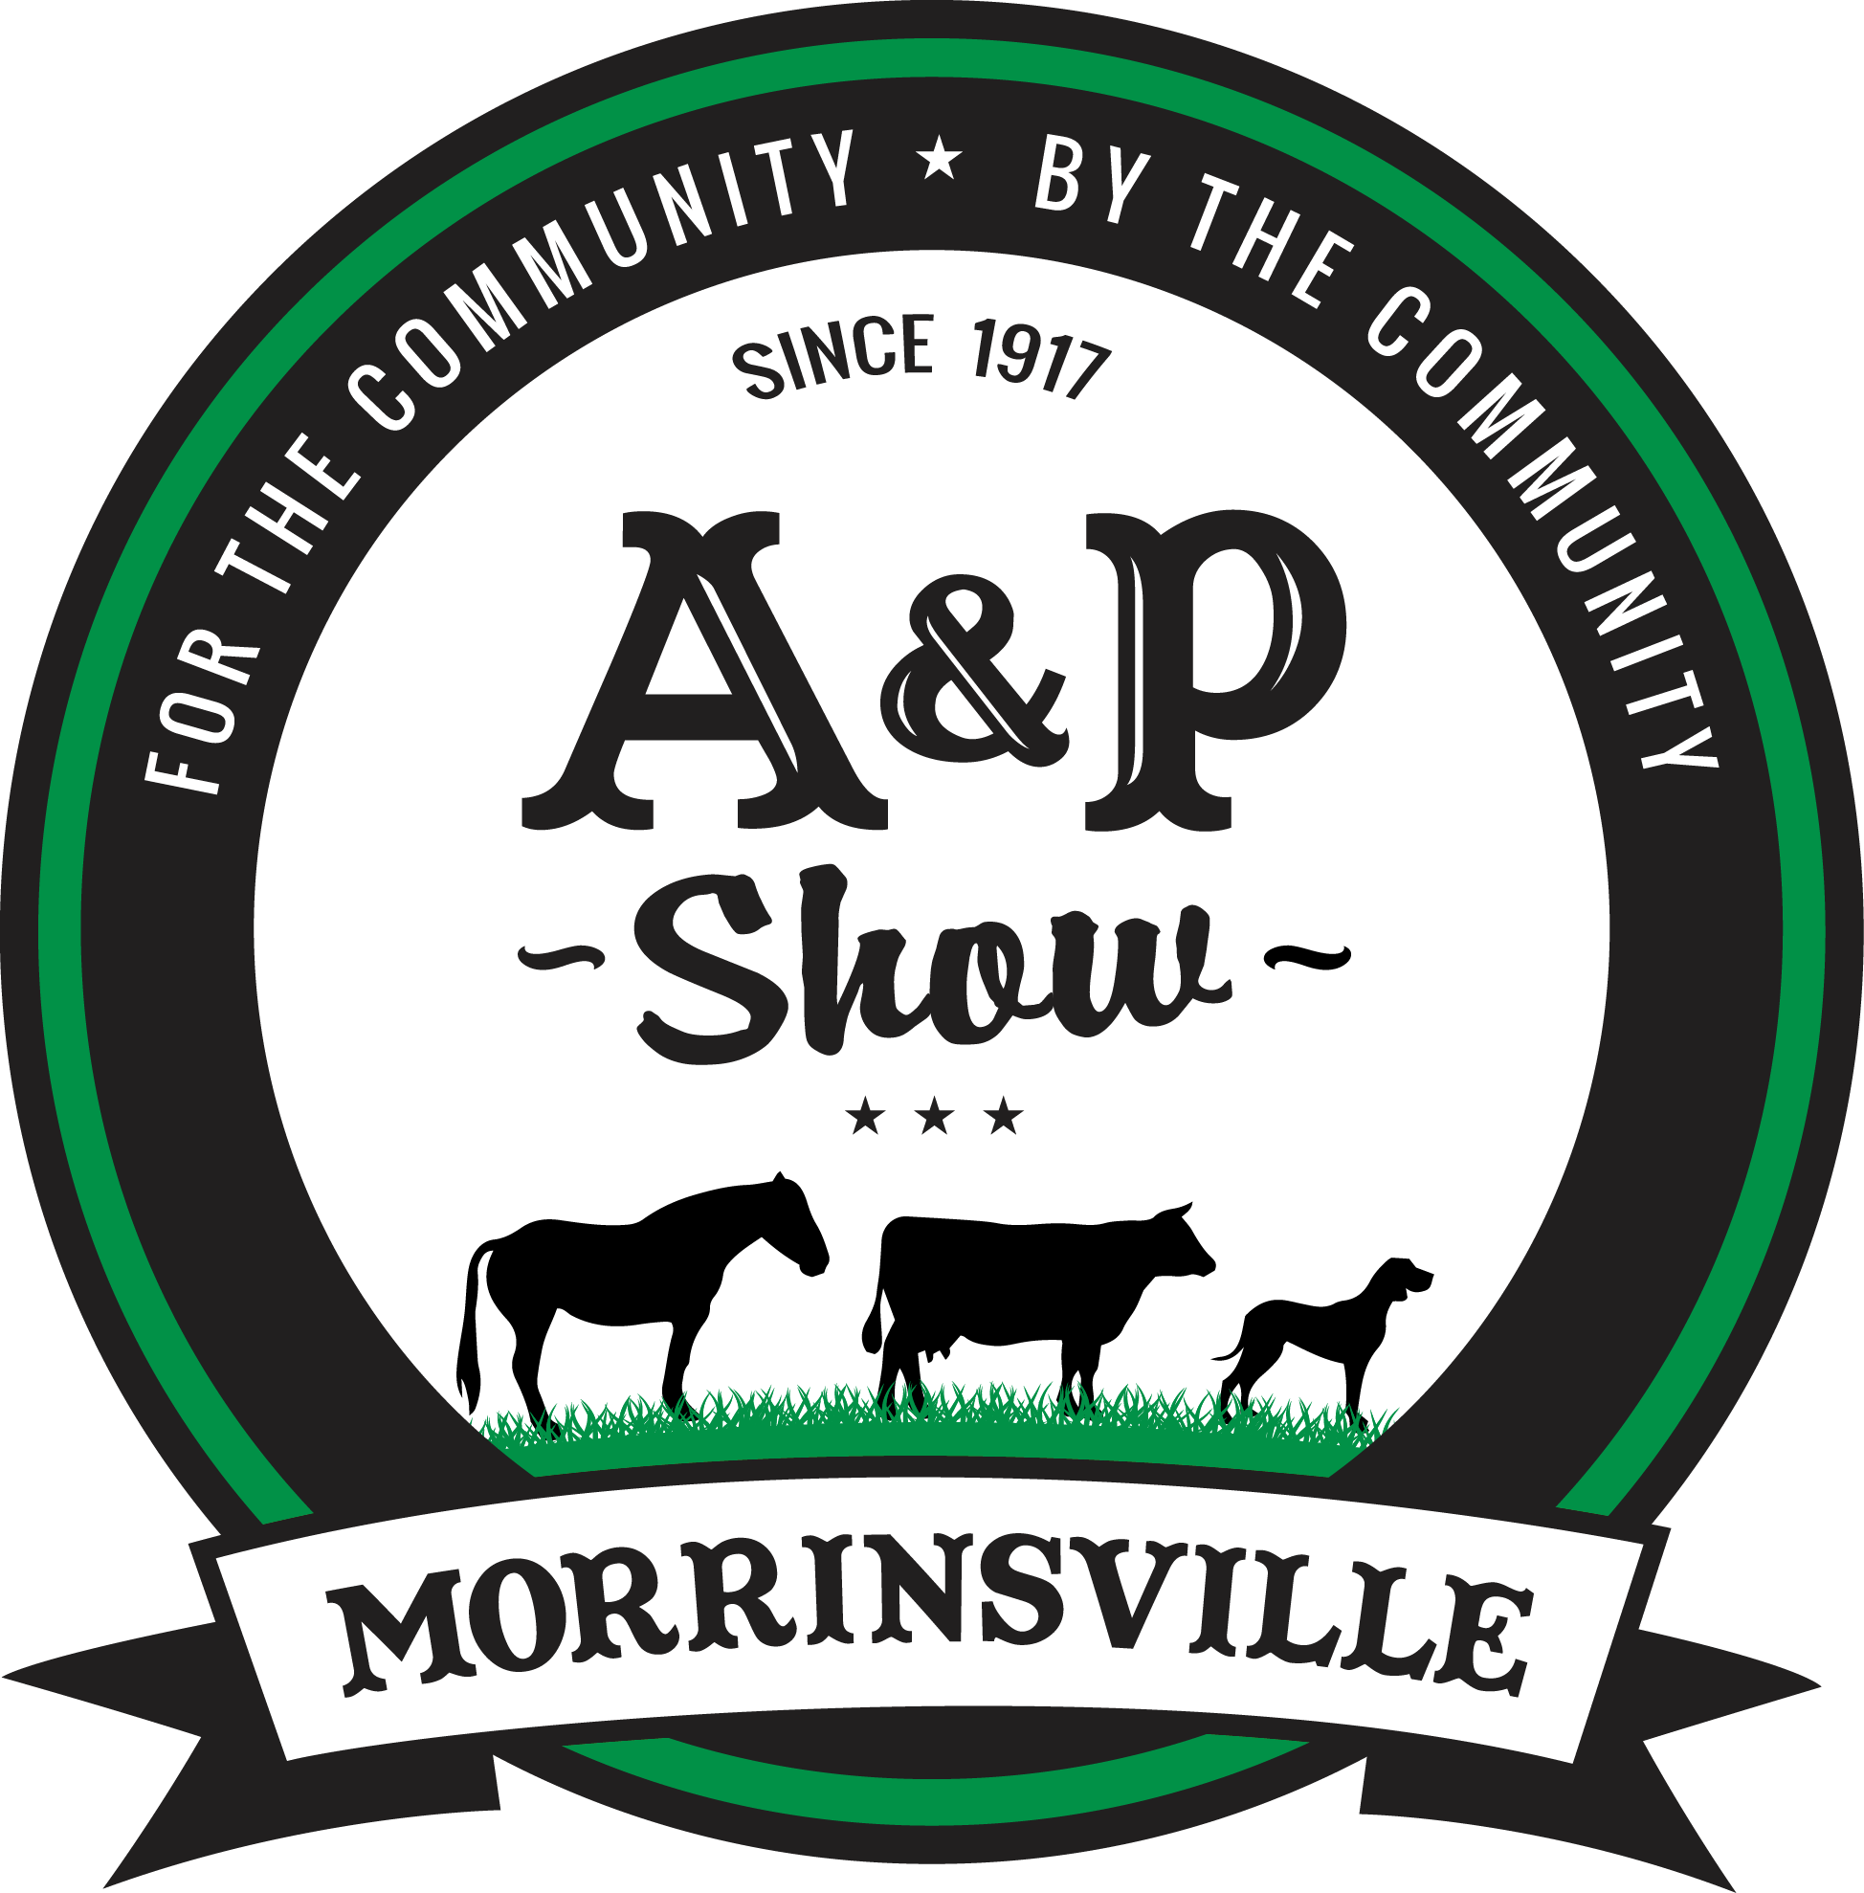 "By the Community, for the Community"

