RAS PRE-REGISTRATION FORM – FIRST MEASURE EVER

OWNER TO COMPLETE THIS SECTION ONLY – Please print clearly
RAS HEAD OFFICE USE ONLY:

RAS Certificate Number A …………………………..

Form Received: ___ / ___ / 20___ Paid $58 on ___ / ___ / 20____
Database: ____ / ____ / 20__ Couriered on ____ / ____ / 20___

NZ Post Bag – Track #

CR #___________________
PAID IN FULL,
NOTHING TO BE PAID AT
MEASURING STAND

MEASURER - CONFIRM & NOTE MICROCHIP # (MN) OR IF NO MICROCHIP COMPLETE MARKINGS & BRANDS IF ANY

MN (or sticker)

Brands (if any) NS OS

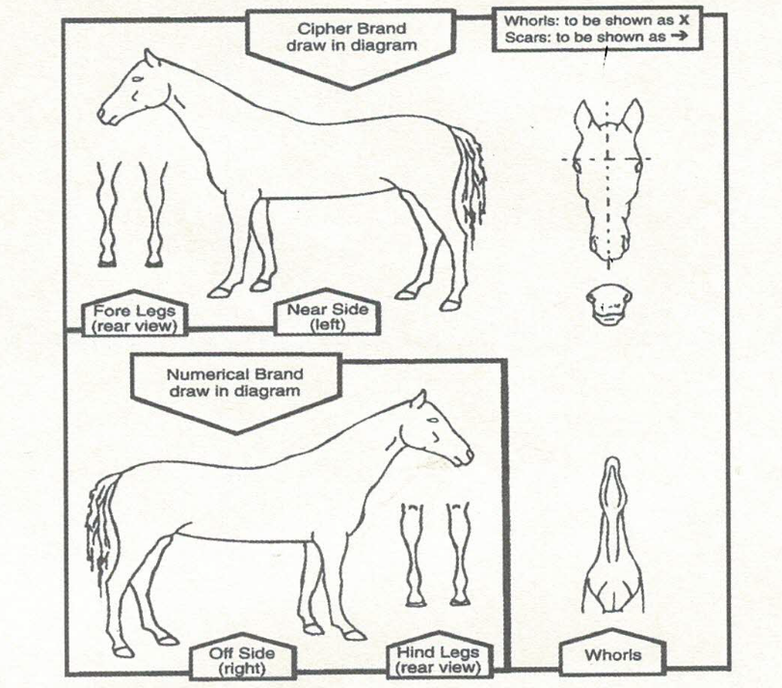
NOTE: DO NOT complete this form and take it straight to the Measuring Stand
without sending it to RAS Head Office first and obtaining a Certificate.
For a Change of Ownership, Replacement Certificate, Lease filed or Change
of Classification please see - https://www.ras.org.nz/equestrian/forms/
* Sections MUST be completed by Owner before emailing through to RAS Head Office
HORSE / PONY (Show Name): *__________________________________
If also registering with ESNZ ensure that they approve the name, before pre-registering with RAS

Colour: *_______________________ DOB-Month:____Year: *______ Sex:* S Stallion)
Breed: ________________________ Breed Reg. #___________ M (Mare)
Section Nominated *_____ (P) Pony: (SHP) Saddle Hunter Pony: (M) Mini G (Gelding)
(HK) Hack/Park Hack: (SH) Saddle Hunter: (RH) Riding Horse: (C) Cob
CURRENT Owner’s Name (18yrs and over): * ____________________________________
Address (include RD#): *_______________________________________________________
____________________________________________________________P/Code *_______
Phone: (0 ) __________________ *and/or Mobile:02 ____________________________
Email: *______________________________________ My signature herewith confirms that I own the
above Horse/Pony, and it has never had a previous Height Certificate under this name or any other name. I confirm I have searched the RAS database to confirm this - https://www.ras.org.nz/equestrian/horse-search/

Current Owner’s Signature: * __________________________ Date: *__________ 20____
PAYMENT – includes NZ Post Tracked Courier Bag (If applying for multiple Pre-Registration
First Ever Measures, only one courier fee ($14) needs to be paid).
*
Direct Credit of $58 made on __ / ___ / 20__ - email form to enquiries@ras.org.nz
National Bank, A/c No.: 06 0501 0528903 00 - state Surname & horse’s name as payment ref.
___________________________________________________________________
MEASURER TO COMPLETE BELOW and PART ON RIGHT
RULE: M9 a) Youngstock Measures issued to a pony or Miniature horse under the age of three years after
August 1 will be valid until January 31st of the following year. M9 b) Measures issued or endorsed after January
1st will be valid until the end of the current Show season i.e. July 31st
First Measure Height | Date of Measure | Expiry Date | Stand #
cm | / /20___ | / /20___
Name of Measurer: _____________________ Signature: _____________________

Name of Witness: _____________________ Signature: _____________________

Original form to be either: emailed to enquiries@ras.org.nz or sent to RAS NZ, 9 Matai Place, Oxford 7430, immediately after measure. A copy is to be retained by the Measuring Stand.

